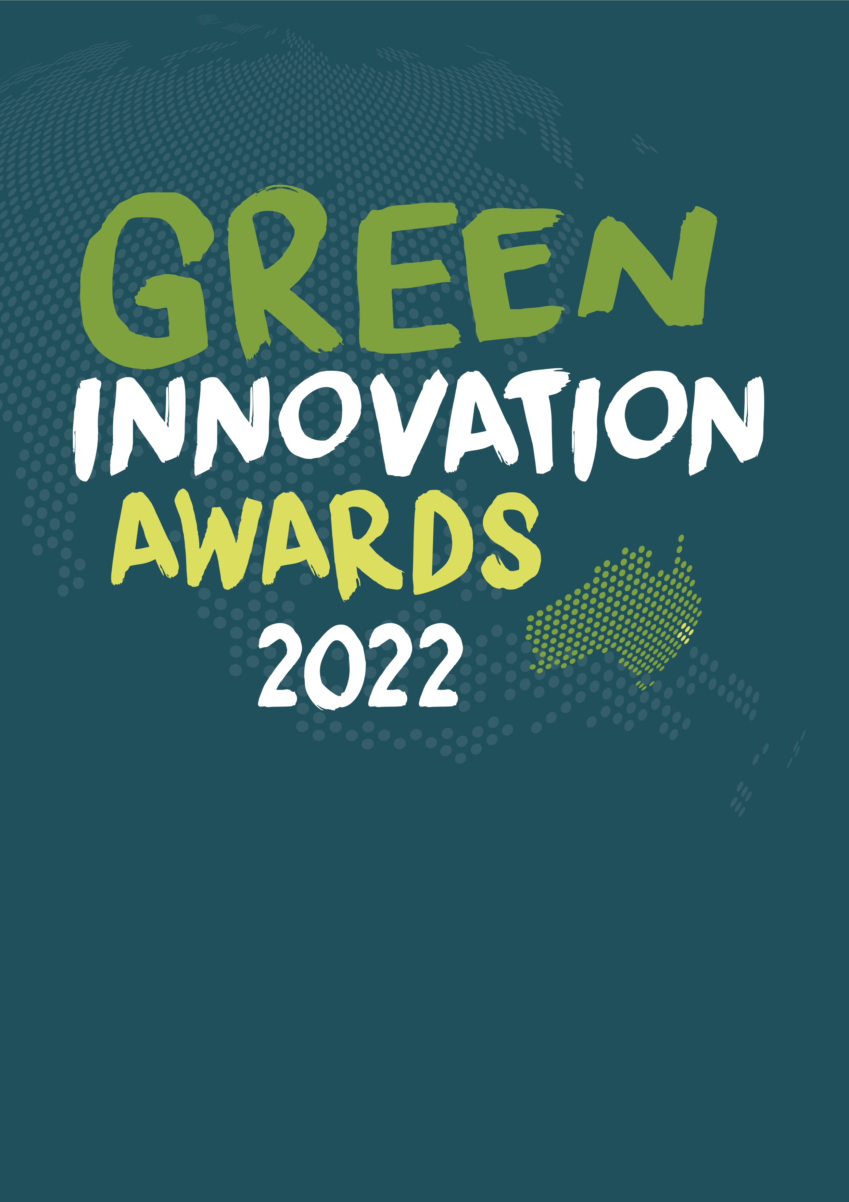G

Proudly supported by

Name/s: ______________________________

STEM & PROJECT BASED LEARNING  
PRIMARY SCHOOL  
 STUDENT BOOKLET

The Green Innovation Awards is a competition to make a *five-minute video* about your solution to an environmental problem. Students can work in groups or as a whole class to enter.   
Two awards of $300 each are presented: Primary School and High School.   
*This booklet outlines the process.­­­­*

TERM 2

TERM 3

* REGISTER YOUR INTEREST BEFORE APRIL 1ST
* IF YOUR CLASS GETS INTO THE FINALS, GO TO SOUTHERN CROSS UNIVERSITY TO PRESENT YOUR PROJECT TO A PANEL OF JUDGES
* WORK ON YOUR PROJECT USING THE RESOURCES PROVIDED
* SUBMIT A VIDEO ENTRY BY THE END OF TERM (JUNE 23RD)

TERM 1

**Areas that you can develop a solution for include:

* Agriculture
* Biofuels / renewable energy
* Green products / recycling
* Water management
* Waste management

To get an idea about past projects, check out the finalists and award winners from previous years at [www.greeninnovationawards.com.au](http://www.greeninnovationawards.com.au) Your project does not have to be 100% original, just 100% your own work and creativity.

|  |  |  |
| --- | --- | --- |
| Step | Activities | Duration |
| Picture 10  IDENTIFY & DEFINE | As a class brainstorm everything you already know about the five areas of interest:   * Agriculture * Biofuels / renewable energy * Green products & recycling * Water management * Waste management | One lesson |
| Picture 10  IDENTIFY & DEFINE | Use computers to research your choice of two of the topics above, identifying existing problems in these areas.  Identify the environmental problem you are trying to solve.  Who does this problem effect and how?  Why is a solution needed? | Two lessons |
| Picture 3  BRAINSTORM/ IDEATE | Brainstorm possible innovative solutions to your problem.  Come up with as many ideas as you can – all team members  must contribute.  Discuss all the ideas and decide on which solution your team  will develop. | One lesson |
| Picture 4  DESIGN/PLAN | Research what has already been done to solve your problem.  Plan out your solution – develop a timeline of activities, draw diagrams, perform research as needed to assist with your planning.  Assign roles to group members. Make sure everyone has a meaningful role that they can achieve. | Two lessons |
| Picture 5  PROTOTYPE /MAKE | Develop a prototype of your solution.  The form of your prototype will depend on your solution:   * Electronic solutions (app, website etc) may have a wire  frame as a prototype. * Physical solutions may have a simple model. | Changeable depending on the  size /type and scope of project. |
| Picture 6  TEST | Test your prototype. This can be done in different ways:   * For a model, test if it does what you want it to do. * Ask classmates for feedback about what works well  and what needs to be improved. * Ask your teacher for feedback. * If you have a target audience, ask them for feedback. | Changeable depending on the  size /type and scope of project. |
| Picture 7  IMPROVE | Based on the feedback from the previous step, make improvements to your solution.  Work your solution up into a more complex/complete prototype. | Changeable depending on the  size /type and scope of project. |
| Picture 8  COMMUNICATE & SHARE | Share your solution with your class.  Enter your solution in the Green Innovation Awards. | One lesson |

Background Research

*As a class brainstorm everything you already know about the five areas  
of interest using the spaces below. Two examples have been provided.*

|  |
| --- |
| *Image*  AGRICULTURE  *Soil erosion*  *Agriculture uses  a lot of water* |

|  |
| --- |
| *Wind & solar electricity*  *Ethanol in petrol*  Image  BIOFUELS/ RENEWABLES |

|  |
| --- |
| *Rainwater tanks*  *Water pollution from household chemicals*  Image  WATER  MANAGEMENT |

|  |
| --- |
| *Avoid single-use items*  *Too much  plastic packaging*  Image  WASTE  MANAGEMENT |

|  |
| --- |
| *We don’t fix things,  we throw them away*  *Compostable plastic bags*  Image  GREEN  PRODUCTS &  RECYCLING |

*Use computers to research your choice of two of the brainstormed ideas above, identifying existing problems in these areas.*

TOPIC 1:

Existing Problems Include:

TOPIC 2:

Existing Problems Include:

*Now that you have done some background research for two different areas,   
choose one area to focus on for your project and answer the following questions.*

Our chosen area of research is _____________________________________________________

Three of the most interesting problems that our research uncovered are

1. ___________________________________________________________________
2. ___________________________________________________________________
3. ___________________________________________________________________

*For each of these three problems, brainstorm as many creative solutions as you can. Include ALL ideas. Use the spaces below.*

POSSIBLE SOLUTIONS TO PROBLEM 1

POSSIBLE SOLUTIONS TO PROBLEM 2

POSSIBLE SOLUTIONS TO PROBLEM 3

*As a group, identify which solution would be the best for a Green Innovation Award project. Write your problem & solution in the box as a statement:*

Because groups will have many different ideas and processes, now you should complete your notes, research and planning in your own notebooks. Use the checklist below and tick off the tasks as you complete them. You do not always have to complete the tasks in the order shown. If at any time during the process, you change your mind about which topic, area or solution you wish to propose for the Innovation Awards, simply go back to your planning and brainstorming and choose another.

|  |  |
| --- | --- |
| TASK | DONE |
| 1. Go to <https://www.greeninnovationawards.com.au/> to register your interest before April 1st. |  |
| 2. As part of the registration process, connect with a mentor. |  |
| 3. Go back to the computers to gather ideas and to research what has already been done to solve the problem you have identified. |  |
| 4. Decide on how you will present your ideas for the Innovation Awards. |  |
| 5. Make sure everyone in the group has meaningful roles to play / tasks  to complete. |  |
| 6. Develop a timeline to show how much time you have and what tasks  you need to complete. |  |
| 7. Develop a prototype of your solution. A prototype is a simplified or shorter  version of the final product. The form of your prototype will depend on your solution; electronic solutions (app, website etc) may have a wire frame as a prototype, whereas physical solutions may have a simple model. The idea here is to FAIL EARLY, so you can correct any problems now. |  |
| 8. Show your prototype to classmates or students in another class.  Collect written or verbal feedback from them. |  |
| 9. Show your prototype to your mentor and get feedback. This should happen early to mid-Term two. |  |
| 10. Use all the feedback to refine your project. Keep working on your project until you have created your final presentation. |  |
| 11. Email your entry as a 5 minute video (MPEG, MP4 or AVI) before the 24th of June (Week 10 Term 2) via Dropbox to [info@greeninnovationawards.com.au](mailto:info@greeninnovationawards.com.au) |  |
| 12. Finalists will present their project to a panel of judges at the Southern Cross University in Week 7 of Term 3. |  |

STEM Design Thinking Process Marking Criteria

|  |  |  |
| --- | --- | --- |
| Phase | Criteria | Marks |
| Picture 10  IDENTIFY & DEFINE | Uses computers to research two topics. Identifies extensive and relevant existing problems in both areas. | 5 |
| Picture 3  BRAINSTORM/IDEATE | Identifies one area of research and three existing problems for  further inquiry.  Demonstrates that a variety of ideas & solutions to the three problems have been formulated and considered. | 5 |
| Picture 4  DESIGN/PLAN | Demonstrates that research has been undertaken in the following areas:   * What is already known about the problem * Solutions that have been tried, along with their successes  and failures * Demonstrates planning by the use of tools such as: Timelines,  Flow charts, Diagrams, Team roles & Procedures | 10 |
| Picture 5  PROTOTYPE /MAKE | Develops at least one prototype such as: Physical models, Wireframes, Diagrams, Promotional materials. | 10 |
| Demonstrates effective time management. | 5 |
| Picture 6  TEST | Demonstrates the prototype/s have been tested and evaluated by:   * Collecting feedback from at least 3 people * Collecting data showing the testing of the prototype * Evidence of success and improvements needed | 10 |
| Demonstrates equitable teamwork | 5 |
| Picture 7  IMPROVE | Demonstrates improvements made to the prototype/s by implementing improvements based on the feedback collected during the previous phase. | 5 |
| Demonstrates resilience when solving problems. | 5 |
| Picture 8  COMMUNICATE & SHARE | Clearly communicates their solution by:   * Identifying the problem they are solving * Describing the solution they investigated * Explaining how the solution solves the problem | 5 |
| Demonstrates effective communication skills. | 5 |
| Final Mark | | 70 |
| Mark as a percentage | |  |

Student Self-Reflection

*Look at the STEM Skills posters and fill out the table below.*

|  |  |  |
| --- | --- | --- |
| Skill | When it was used | How it was used |
| Communication |  |  |
| Teamwork |  |  |
| Problem Solving |  |  |
| Critical Thinking |  |  |
| Creativity and Innovation |  |  |